**Chat Functionality**

1. Chat with Particular User (1 to 1).
2. Chat In a Group.
   1. User can create a chat group with unique name.
   2. User can join existing chat group.
3. User can do chat in below ways.
   1. Text Chat.
   2. Records audio and send it to particular user or in group like WhatsApp.(Need R&D to check feasibility in website)
   3. Record screens (videos) and send it to particular user or in group. (Need R&D to check feasibility in website)
   4. Send screenshots using snipping tool. (Need R&D to check feasibility in website)
4. Chat window will have white JG logo as a background water mark image.
5. Chat window will have 2 color bubble there.
   1. Sender will see his chat into black bubble.
   2. Sender will see date and time stamp right aligned under chat bubble and into white text except (EST) written in red font. Refer image below. 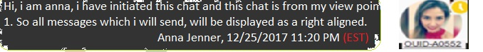
   3. Receiver will see his chat into red bubble.
   4. Receiver will see date and time stamp right aligned under chat bubble and into black text except (EST) written in white font. Refer image below. 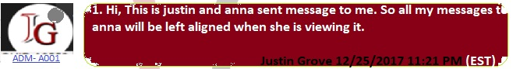
6. User display for different statuses.
   1. When user is online, but ideal into chat window for more than 15 minutes, he will have amber color dot over his profile picture to show him as an idle person. Refer below image.   
      
   2. When user is online, he will have green color dot over his profile picture to show him as an active person. Refer below image.  
      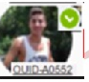
   3. When user is offline, he will have gray color dot over his profile picture to show him as an offline person. refer below image  
      
7. When message is posted by any user first time, it can have 2 scenarios
   * 1. When user is online into system, it will send message to user in chat window using signal R which will pop up into user’s console.
        1. When user is online, small green dot will be displayed on his profile in chat window.
        2. When user is online but not active for more than 15 mins, he will be having amber dot on his profile.
     2. When user is offline and not logged into system, he will sent an email like we are sending currently in Touch Point log.
        1. When user is offline, small gray dot will be displayed on his profile in chat window.
   1. Check freelancer.com as a reference.
8. Chat can be 1 to 1 and 1 to many
   1. When user send message to some person, chat will be 1-1.
   2. When someone, either sender or receiver inside chat window, add someone by @mention into chat, chat will become 1 to many and every one will be able to get chat notification.
9. Chat notifications
   1. User can minimize chat window inside his software screen.
   2. When user is online and someone send message to him, it will popup window to user with sound notification.
   3. When user is offline and someone send message to him, it will send an email to user about message. Reuse source code of existing touch point log. Also when user will logged in he will see unread message count into his telecom dashboard.
10. Chat time stamp
    1. When user send message to other user, it will show up 2 gray check mark as a sent notification.  
       ebc53714-9917-4f1f-ade7-fe754b92e8dd-image.png (341×28)
    2. When other user open that through chat bubble, 2 gray mark will turn in blue color with user read time stamp in user's local time stamp from (stored chat database time stamp in EST).  
       1685034b-05d8-45df-9ca1-92cd6d249c44-image.png (348×34)
11. 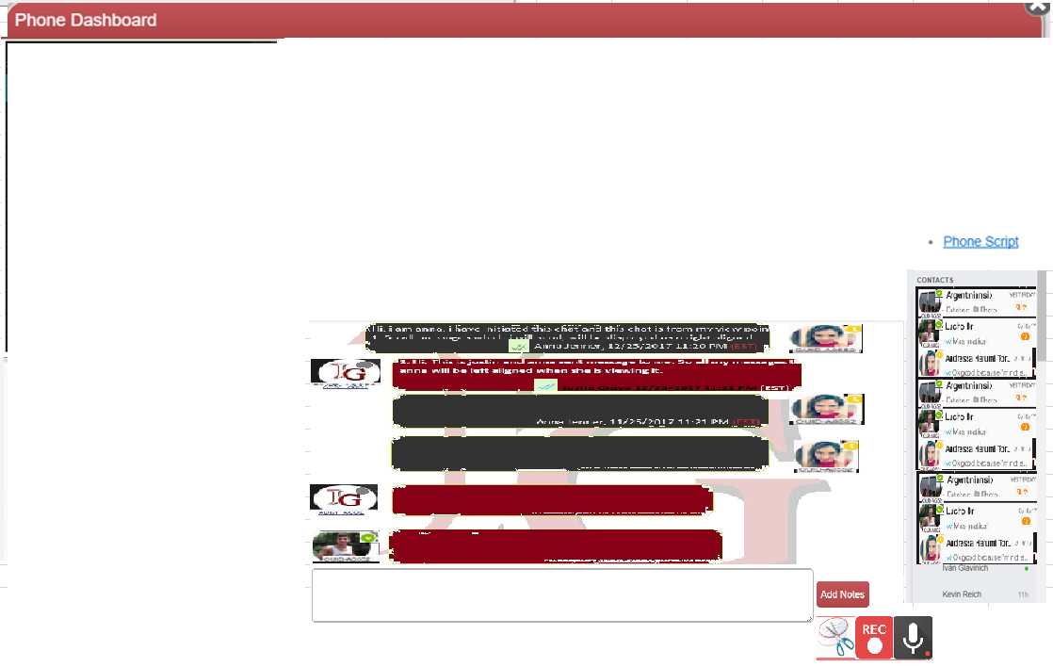
    1. When user clicks on touchpoint log section of edit sales page, it will open up popup displayed same as above image.
    2. On top hand right corner of every page, there are 3 links, Email, Phone, Chat. That should be single link and it will open same pop up.  
        c367f5ff-69fa-400d-9229-85a2b8b1c31f-Telecom-Dashboard-Link.png (270×44)
    3. 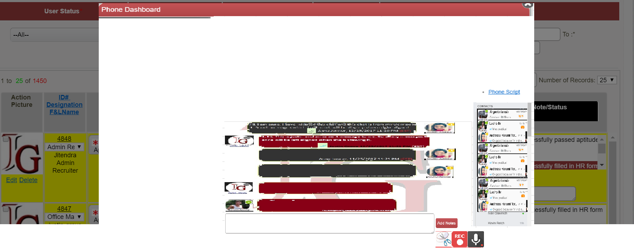  
       When user will reply to email from touch point log, he will be automatically redirected to his default dashboard with telecom popup open to that chat.